**Specialist Mathematics Units 3 & 4**

**Investigation 2 2018**

**Numerical Integration – In Class Validation**

**NAME: ____________________________________**

**TOTAL MARKS: 54 MARKS TIME: 55 MINUTES**

**CALCULATORS & TAKE HOME PAPER ALLOWED**

**A QUESTION OF ACCURACY**

This investigation involves a variety of numerical methods used to evaluate integrals. Throughout you are required to give **final results correct to 3 decimal places**. To achieve this degree of accuracy, you will need to carry extra decimal places in earlier calculations.

When justifying your solutions you may use the sigma symbol with the correct formula, where appropriate, rather showing the full list of values.

**______________________________________________________________________________**

**Question 1 [4,4,5,5,8 = 26 marks]**

For the function $f(x)=\frac{x^{2}(9-x)}{20}$

a) Use the Trapezium Rule to find the total cross sectional area between $x=2$ and $x=8$

i) using 4 strips of equal width

✓ ✓ ✓

Area = $\frac{1.5}{2}$ [ 1.4 + 3.2 + 2(3.36875 + 5 + 5.28125 )]

= 23.925 units2 ✓

|  |  |
| --- | --- |
|  |  |
| 2 | 1.4 |
| 2.5 | 2.03125 |
| 3 | 2.7 |
| 3.5 | 3.36875 |
| 4 | 4 |
| 4.5 | 4.55625 |
| 5 | 5 |
| 5.5 | 5.29375 |
| 6 | 5.4 |
| 6.5 | 5.28125 |
| 7 | 4.9 |
| 7.5 | 4.21875 |
| 8 | 3.2 |

✓ ✓ ✓

or $\frac{3}{4}$ [ $\sum_{i=0}^{3}{f(2+1.5i}$) + $\sum_{i=1}^{4}{f(2+1.5i})$]

ii) and 12 strips of equal width

* ✓ ✓

Area = $\frac{0.5}{2}$ [ 1.4 + 3.2 + 2(2.03125 + 2.7 + 3.36875 + 4 +4.55625 + 5 + 5.29375 + 5.4 + 5.28125 + 4.9 + 4.21875 )]

✓ ✓ ✓

or $\frac{1}{4}$ [$\sum_{i=0}^{11}{f(2+0.5i}$) + $\sum_{i=1}^{12}{f(2+0.5i})$]

= 24.525 units2 ✓

b) Use Simpson’s rule to evaluate the same cross sectional area

|  |  |
| --- | --- |
| $$x$$ | $$f(x)$$ |
| 2 | 1.4 |
| 2.5 | 2.03125 |
| 3 | 2.7 |
| 3.5 | 3.36875 |
| 4 | 4 |
| 4.5 | 4.55625 |
| 5 | 5 |
| 5.5 | 5.29375 |
| 6 | 5.4 |
| 6.5 | 5.28125 |
| 7 | 4.9 |
| 7.5 | 4.21875 |
| 8 | 3.2 |

i) using 4 strips of equal width

✓ ✓ ✓ ✓

Area = $\frac{1.5}{3}$ [ 1.4 + 3.2 + 4(3.36875 + 5.28125 )] + 2 $×5$

= 24.6 units2 ✓

✓ ✓ ✓ ✓

or [) + ]

ii) and 12 strips of equal width

✓ ✓ ✓ ✓ ✓

Area = $\frac{0.5}{3}$ [ 1.4 + 3.2 + 4(2.03125 + 3.36875 + 4.55625 +

✓

5.29375 + 5.28125 + 4.21875 ) + 2(2.7 + 4 + 5 + 5.4 + 4.9 ) ]

✓ ✓ ✓ ✓

or $\frac{1}{6}$ [$1.4+3.2+4 ×\sum_{i=0}^{5}{f(2.5+i}$) + $\sum_{i=1}^{5}{f(2+i})$]

= 24.624 units2 ✓

c) Assume that the function $f(x)=\frac{x^{2}(9-x)}{20}$ is the shape of the tunnel with each unit representing

one metre.

Using the largest percentage error featured above, how much more earth would be estimated to be removed than necessary if the tunnel is 400m long ?

$\int_{2}^{8}{\frac{x^{2}(9-x)}{20}})dx$ by integration using an antiderivative is 24.6units2 ✓

Percentage error Trapezium Rule 4 strips = $\frac{24.6-23.925}{24.6}×100$ = 2.744 % ( 2.743902439 ) ✓

Percentage error Trapezium Rule 12 strips = $\frac{24.6-24.525 }{24.6}×100$ = 0.305 % ( 0.3048780488 ) ✓

Percentage error Simpson’s Rule 4 strips = $\frac{24.6-24.6}{24.6}×100$ = 0.000 % ✓

Percentage error Simpson’s Rule 12 strips = $\frac{24.624 -24.6}{24.6}×100$ = 0.09800 % ( 0.09756097561 ) ✓

Largest percentage error is 2.744% ✓

So estimate of earth removed is out by 2.743902439 $\%$ x 400 x 24.6 ✓

= 289.756 m3  ✓

**MID POINT RULE**

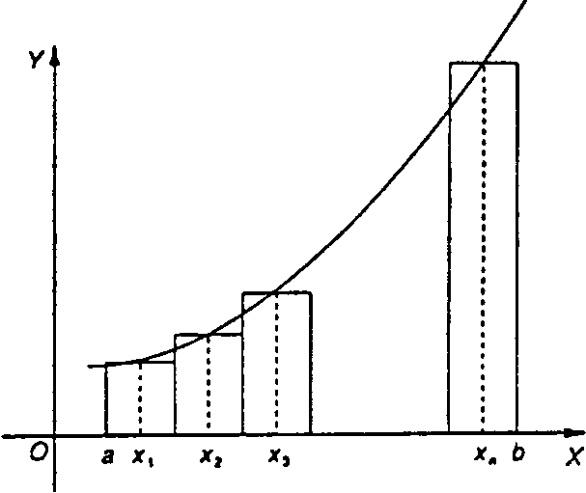Let f be a continuous function in the interval [a; b]. Divide this interval into n subdivisions, each of width

Using these subdivisions as bases, n rectangles are drawn of width w and height f(x1), f(x2), f(x3) where x1,x2, x3are the x-coordinates of the mid-point of the subdivision, as illustrated in the figure below.

A numerical method of approximating the area of the region bounded by the curve the x-axis and the ordinates x=a and x= b is to calculate the sum of the areas of these rectangles:

Example

Use the mid-point rule to find, approximately, the area bounded by the parabola defined by , the x-axis and the lines x = 1 and x = 3, using four intervals.

The x-coordinates of the mid-points of each of the four intervals are x = 1.25, 1.75, 2.25 and 2.75 and .

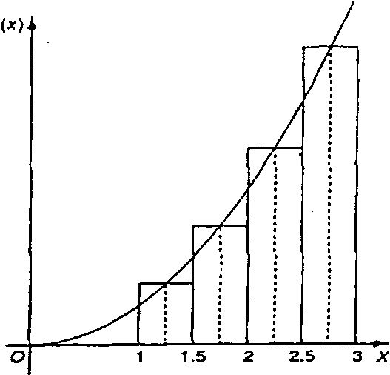 =

[f(l.25) + f (1.75) + f (2.25) + f (2.75)]

[l.5625 + 3.0625 +5.0625 + 7.5625]



|  |  |
| --- | --- |
| $$x$$ | $$f(x)$$ |
| 0 | 2 |
| 0.1 | 2.210341836 |
| 0.125 | 2.266296906 |
| 0.2 | 20442805516 |
| 0.25 | 2.568050833 |
| 0.3 | 2.699717615 |
| 0.375 | 2.909982829 |
| 0.4 | 2.983649395 |
| 0.5 | 3.297442541 |
| 0.6 | 3.644237601 |
| 0.625 | 3.736491915 |
| 0.7 | 4.027505415 |
| 0.75 | 4.234000033 |
| 0.8 | 4.451081857 |
| 0.875 | 4.797750588 |
| 0.9 | 4.919206222 |
| 1.0 | 5.436563657 |

**Question 2 [ 4,4,5,8,7 = 28 marks]**

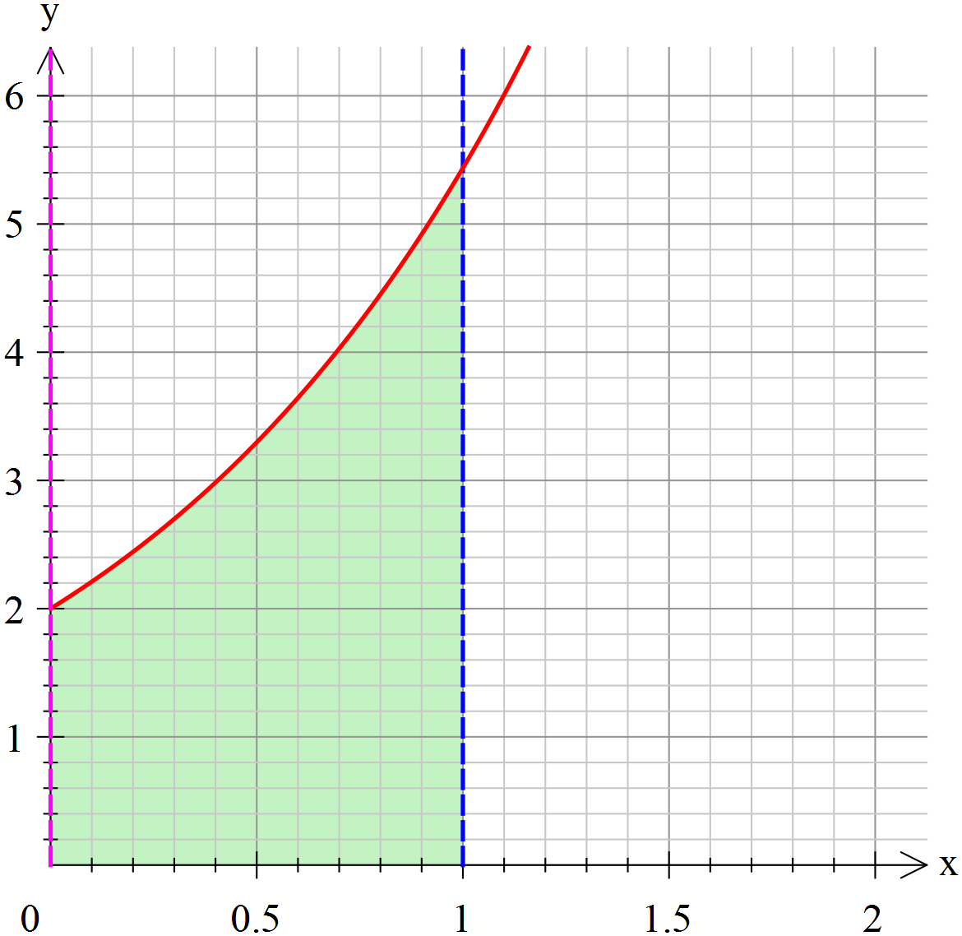

The graph and table shown show the graph of $y=f(x)$.

A table of values accompanies the graph.

Use 4 strips with each of the following methods to estimate the area under the graph corresponding to $\int_{0}^{1}{f\left(x\right)dx}$.

a) Mid-point method

Area = [ ]

✓ ✓ ✓

= [ ]

3.428 units2 (3.42763056)

b) Trapezium Rule

Area = [ ]

✓ ✓ ✓

= []

3.454 units2 ✓ ( 3.454443809)

c) Simpson’s Rule

Area = [ ]

✓ ✓ ✓ ✓

= []

3.437 units2 ✓ (3.436637684)

d) Use percentage errors to compare the relative accuracies of each method if the area under the graph is 3.436563657 units2.

Percentage Errors

✓ ✓

Mid-point Rule: $\frac{3.42763056-3.436563657 }{3.436563657 }×100$ $≈$ 0.260% (-0.2599427187)

✓ ✓

Trapezium Rule: $\frac{3.454443809-3.436563657 }{3.436563657 }×100$ $≈$ 0.521% (0.520291599)

✓ ✓

Simson’s Rule: $\frac{3.436637684-3.436563657 }{3.436563657 }×100$ $≈$ 0.002% (0.00215408736)

Simpson’s Rule gives the most accurate estimate, ✓ by a long way, more than 100 times more accurate.

The least accurate is the Trapezium Rule, in this case. ✓

d) What advantage does each rule have ? Include any general observations you may like to add.

The Mid-point Rule is the easier of the three to calculate, and would be used for a ”quick” estimate. ✓

The Trapezium Rule is easier to calculate than Simpson’s Rule ✓, and should be more accurate than the Midpoint Rule with larger widths of strip or if the function is more undulating. ✓

Simson’s Rule can only be used for even number of strips. ✓ It is more accurate ✓because it approximates a curve with a parabola rather than a straight line. ✓

It is a weighted means version of the two other rules examined. ✓

(Any other relevant considerations should be rewarded.)